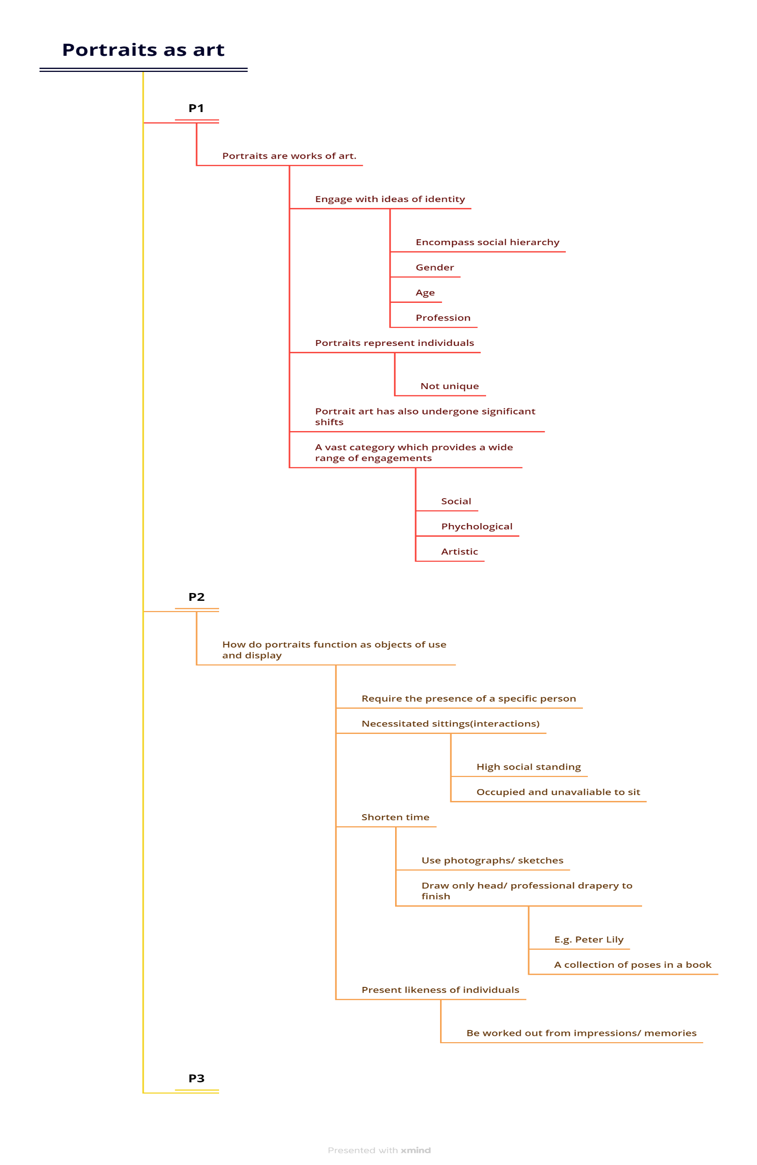

-Human rights groups in Haiti have told the BBC that heavily-armed gangs now control more than half of the capital poster prints and surrounding areas. Hundreds of people have been killed in gang-related fights.

China appears to be dismantling its policy of covid testing, part of its zero-covid strategy. Residents in Beijing and Shanghai no longer need to show proof of negative test on public transport.

? in Ukraine have suffered casualties as the ground war between the two continues alongside further missile strikes.

Plays kicking off at the world cup in Qatar shortly with Japan taking on Croatia and south Korea is playing on Brazil.